Lent 2022
Following Christ in the Footsteps of the Saints
Guided by the story of St Winefride/Gwenffrewi

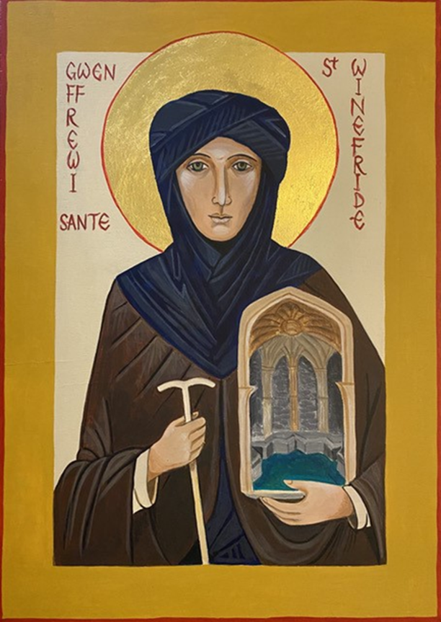

How to use these resources
This journey through Lent draws upon the 16 individual resources on St Winefride put together by the Mission Theology Advisory Group (MTAG) and links to a 70-mile pilgrimage from Holywell, Wales, to Shrewsbury in April and May 2022, led by Bishop Sarah Bullock from the Anglican Diocese of Lichfield. The pack of resources is available from https://www.lichfield.anglican.org/our-faith/pilgrimage/ under ‘St Winefride Pilgrim Trail’, and also from https://www.churchofengland.org/resources/deeper-god-mission-theology or from https://ctbi.org.uk/mission-theology-advisory-group-resources/
These resources will help you follow the St Winefride ‘thread’ which runs through this Lent material. The resources take you more deeply into the traditional accounts of St Winefride, whose story has many touchpoints with our modern world – sexual harassment and coercion, misuse of power, the place of faith and the right to follow Jesus, and the contemporary need for healing and hope. (A synopsis of St Winefride’s story is given below).
However, if you don’t want to use the St Winefride resources, you can still use all this material for groups or for your personal journey through Lent, because other options, based on the Scripture for the day, are also provided from the Revised Common Lectionary. Or you can mix and match.
Each station on the journey for Ash Wednesday and for each week in Lent starts from a piece of Scripture set for the day, and offers something to talk about together, something to reflect on, something to do and something to deepen our Christian lives as disciples as we seek to follow Jesus Christ more faithfully. Each station on the way then concludes with prayer.
Depending on how you like to engage with Lenten material you can pick one of the sections and concentrate on that, or use some or all of them in the course of a session or even over a week. So we have provided:
Station 1 – questions and conversation starters if you like to talk about a topic.
Station 2 – food for thought – maybe something you haven’t thought about before.
Station 3 – something to do: practical action for you to engage with your community.
Station 4 – something to take you deeper into being a follower of Jesus.
Station 5 – a prayer to say together or to think about after the session.
We have provided you with a version with pictures for online exploration and a text only version if you want to print the Lent resources out. Questions? Contact Dr Anne Richards, MTAG convener, at anne.richards@churchofengland.org
St. Winefride (also Gewnffrewi or Gwenfrewi) is thought to have been the daughter of a 7th century Welsh noble family, living in what is now the border country between England and Wales. Winefride was a faithful Christian, keen to learn about Jesus and to follow him, encouraged and taught by her uncle, Beuno. Dedication and commitment to her faith resulted in Winefride’s violent death, by decapitation, when she tried to escape the insistent advances of Caradog (also spelled Caradoc), a man from an aristocratic family who threatened to sexually attack her if she did not agree to marry him. At the place where her head fell to the ground, now called Holywell, a well of pure water sprang from the earth. Beuno, who was praying nearby, picked up her head, replaced it on her body, and she lived. Winefride continued to live a life of great holiness and became abbess of a nunnery at Gwytherin, North Wales. Her remains brought from Gwytherin to Shrewsbury Abbey in 1137 despite local opposition, and St Beuno’s remains stolen and brought to the Abbey later. More at https://www.lichfield.anglican.org/news/following-christ-in-the-footsteps-of-the-saints.php
Ash Wednesday (2nd March 2022)
Starting from today’s Scripture readings
Matthew 6:19-21
Original photo: Holly Victoria Norval/flickr

Do not store up for yourselves treasures on earth, where moth and rust consume and where thieves break in and steal; but store up for yourselves treasures in heaven, where neither moth nor rust consumes and where thieves do not break in and steal. For where your treasure is, there your heart will be also.

1 Something to talk about together:
*What do you think Jesus means by ‘treasure in heaven’?
*In the story of St Winefride, she rejects earthly pleasures for a life of devotion to God. How difficult do you think it can be to follow Jesus in this way?

2 Something to reflect on
*Jesus makes the point that earthly treasure doesn’t last. Have you ever discovered that a possession has been spoiled by mould or rust or had something you valued stolen? What happened and what did that feel like?
*In the story of St Winefride, she loses her life for refusing to become someone else’s possession. Yet she is restored to life and as people search out her healing spring in pilgrimage, healing and restoration can be experienced by others. How could this help us understand what Jesus means by ‘treasures in heaven’?

3 Something to do
*Think about what ‘treasure on earth’ you might possess. What things might be hard to give up and why? What are the easiest things to give up? Think about whether you could donate or give away ONE thing from your earthly treasure and replace it with ONE thing which would represent heavenly treasure, such as a commitment to pray for whoever receives your donated item.
*In the story of St Winefride, she and St Beuno talk of ‘heavenly things’ together. Who do you know who could help you lay up ‘treasure in heaven’ by helping you deepen your relationship with Jesus?

4 Going Deeper
*Jesus makes the point that our hearts, our inner selves, are directed to whatever we most value – and often that’s the possessions and pleasures of the world rather than trying to create a deeper and more fruitful relationship with God, discerning God’s will for us. In Lent, we hear of the temptations of power and riches that were put before Jesus, how he struggled with those empty promises and how he overcame them. How can we learn from Jesus’s example and overcome our own temptations?
*In the story of St Winefride, she came from an aristocratic family, but decided to choose a life of poverty, chastity and obedience. How can we learn from the example of those who choose the religious life? Who could we follow to inspire us to grow in holiness and discipleship?

5 A Prayer
Lord Jesus Christ,
We thank you for calling us to be people
who store up treasure in heaven rather than in this world.
Help us to be less possessive, less obsessed with things that do not last,
and, on Ash Wednesday, when we remember that we too are dust,
and that all things pass,
let us look towards your heavenly kingdom,
and to the sure and certain hope of life eternal.
Amen

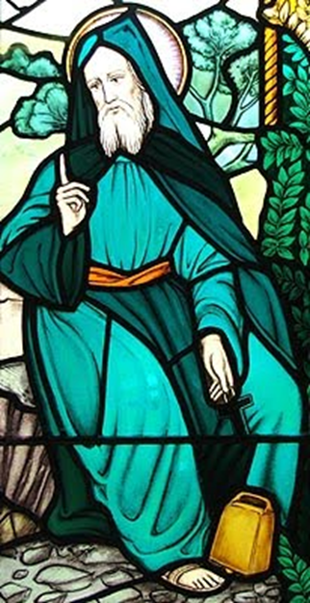
St Beuno talking with St Winefride of ‘heavenly things’
Lent 1 (6th March 2022)
Starting from today’s Scripture readings
Romans 10:11-13
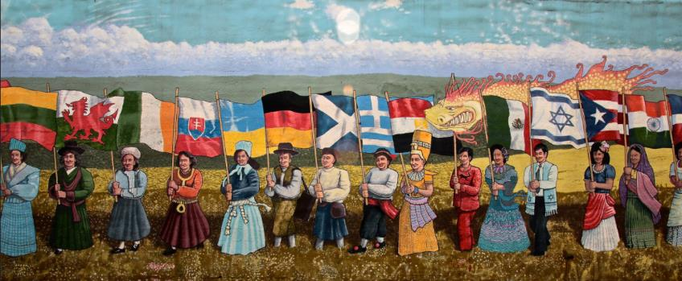
Original photo: R Miller/flickr Diversity

The scripture says, "No one who believes in him will be put to shame. For there is no distinction between Jew and Greek; the same Lord is Lord of all and is generous to all who call on him. For, "Everyone who calls on the name of the Lord shall be saved”.

1 Something to talk about together
*What do you think this passage tells us about the nature of God and what God wants for human beings? How does God encourage us to cross borders and boundaries and show that the same Lord is Lord of all?
*In the story of St Winefride, when she was harassed by Caradog, she tried to make for the sanctuary of a church. In what ways can the church be sanctuary for people today? How can ecumenical and cross border relationships build up the Church in fellowship? Are there divisions which need to be healed?
2 Something to reflect on
*The Scripture directs us to think about God’s generosity and mercy. Do we show that same generosity and mercy in our own lives as Christians? Are there people in need of Jesus Christ around us whom we ‘put to shame’ by our thoughts, words and deeds? How could we live more generous, more merciful, Christian lives?
*Where do you see God’s generosity and mercy in the story of St Winefride? How might telling her story help others to see more of what the Scripture is talking about?
3 Something to do
*Think about a person, or a family, or even a community in your local area, whose people are very different from you. They might be different in ethnicity, heritage, culture, religion, views, language-use, or simply likes or dislikes. Think of a way in which you could show generosity to them and carry it out. It could be something as simple as calling round, explaining that it’s Lent and whether there’s anything they would like you to pray for. Or you could organise an event to which they are invited or find something practical to do together.
*Have a think about why the idea of ‘pilgrimage’ is becoming ever more popular with spiritual seekers. Can you think of some people local to you, who are not Christians, but who might enjoy an invitation to join the St Winefride’s pilgrimage? You could use the St Winefride resources to make sure you can answer any questions about why the pilgrimage is happening and what her story is all about. https://www.lichfield.anglican.org/season-of-pilgrimage.php
4 Going Deeper
*We know from Acts that there were a lot of people who were pretty convinced that there were some big differences between Jews and Greeks. And this raised a powerful theological question for the early church – was salvation in Jesus Christ available to everyone or not? So these words from Romans offer us a serious challenge, even today. For example, some people believe that some migrants convert to Christianity in order to claim asylum. Do such reports make us feel less generous? How do we relate to the words ‘everyone who calls on the name of the Lord will be saved’?
*In the story of St Winefride, we see a woman who was about to be raped being saved both physically and spiritually. But at the same time, she also made a plan to escape and use her faith and the Church to get away from being used as a possession. Do you think she was intending to ‘use’ the Church to get away from the world she lived in? How might her story help us navigate vexed questions about conversion and calls on the generosity of Christians?
5 A Prayer
Lord Jesus Christ,
we thank you for your generous mercy
towards all who call on you.
Help us this Lent always to be more kind,
more generous, more loving towards others.
Help us too, to love before we judge,
to see what unites us rather than divides us:
to be wise as serpents and harmless as doves.
For your name’s sake,
Amen

Original photo: Nathan/flickr

Lent 2 (13th March 2022)
Starting from today’s Scripture readings
Philippians 3:17-4:1
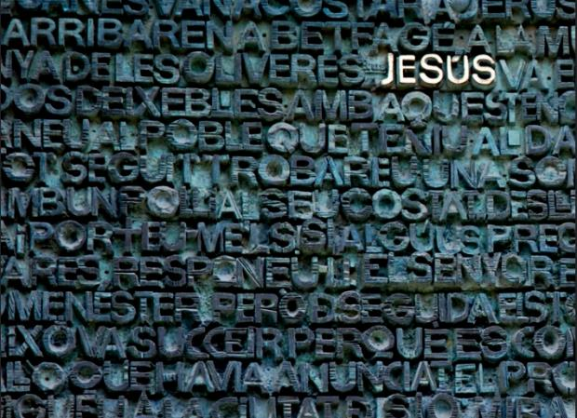
Original photo: Larissa S /flickr

Brothers and sisters, join in imitating me, and observe those who live according to the example you have in us. For many live as enemies of the cross of Christ; I have often told you of them, and now I tell you even with tears. Their end is destruction; their god is the belly; and their glory is in their shame; their minds are set on earthly things. But our citizenship is in heaven, and it is from there that we are expecting a Saviour, the Lord Jesus Christ. He will transform the body of our humiliation that it may be conformed to the body of his glory, by the power that also enables him to make all things subject to himself. Therefore, my brothers and sisters, whom I love and long for, my joy and crown, stand firm in the Lord in this way, my beloved.

1 Something to talk about together
*As we journey through Lent, how can we show others that we are citizens of heaven and that we expect a Saviour, the Lord Jesus Christ? Can we find ways to express our hope and expectation which make sense to others? How can we show people a joyful hope?
*In the story of St Winefride, we see in Caradog a particular example of someone who fits the description in the Scripture of an enemy of the cross of Christ. We also see from the story that he was apparently destroyed by being swallowed up by the earth. How could we use the story to encourage people who are struggling with faith and feel discouraged by the negative opinions of others?
2 Something to reflect on
*What do you think it means today to ‘stand firm in the Lord’? What is it like to be humiliated, dismissed or mocked for being a Christian, or indeed anything about your life that is important to you?
*In the story of St Winefride, she stood firm in her intention to follow Jesus Christ and dedicate herself entirely to his service, but Caradog thought he was utterly humiliating her by catching and murdering her. What might people have thought about the ways of the world if the story had stopped at that point? What other examples can you think of where God has vindicated people who have been hurt in pursuit of their determination to follow Jesus Christ?
3 Something to do
*This passage of Scripture about the persecution of Christians in the early church and the urgent call to stand firm in the faith, might remind us that so many Christians across the world are still being persecuted today. And people are still being tortured and humiliated if they refuse to renounce Jesus Christ. One thing we could do is to look for stories in the news about brothers and sisters who are being persecuted in this way and pray for them, or light a candle for them. We could also find out more about charities and agencies who work on behalf of persecuted Christians and support them in time, finance, action, or prayer.
*Using some underlying themes from the story of St Winefride – violence against women and men, harassment, evil use of power, humiliation and coercion, have a look round your local area for charities, agencies and services which seek to help vulnerable people who have suffered abuse or are in trouble. Choose ONE local service or agency and find a way to show them some practical support, such as donating food or clothing,
4 Going Deeper
*On this Lenten journey, it would be good to find ways of recommitting to Christian faith. That might be reflecting on our baptism and recommitting to baptismal vows. Or we could perhaps commit to praying or reading the Bible more regularly or to living by a simple rule of life. Find something which works for you and commit to it for the rest of Lent.
*When in the story St Winefride is healed by St Beuno, how might this be a picture in human terms of the healing and transformation that is referred to in this passage of Philippians? If you were trying to explain to someone who is not a Christian what is meant by the power of Jesus in the scripture, what kind of story might you want to tell that illustrates this?
5 A Prayer
Lord Jesus Christ,
We recommit our lives to you,
as we seek to stand firm for love of you.
Help us to keep our eyes on the promise of your glory,
and to help the weak, the struggling,
the friendless, the powerless and the vulnerable.
Help us to witness to your transforming love
that at the end will wipe all tears away.
Amen

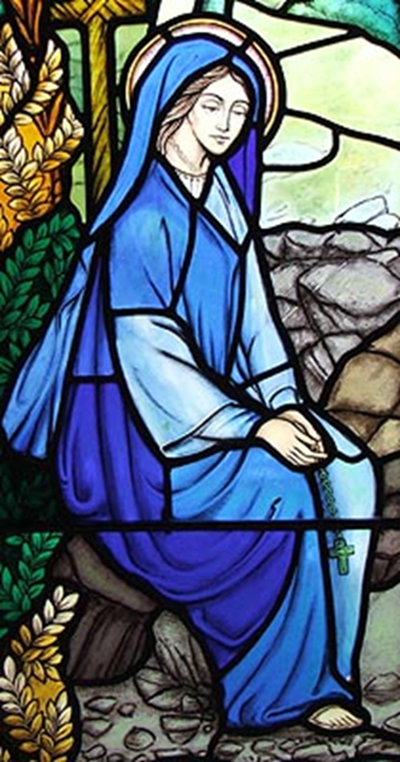
St Winefride talking with her spiritual mentor, St Beuno
Lent 3 (20th March 2022)
Starting from today’s Scripture readings
Isaiah 55:4-9

Captured moments by Angela/flickr
See, I made him a witness to the peoples, a leader and commander for the peoples. See, you shall call nations that you do not know, and nations that do not know you shall run to you, because of the LORD your God, the Holy One of Israel, for he has glorified you. Seek the LORD while he may be found, call upon him while he is near; let the wicked forsake their way, and the unrighteous their thoughts; let them return to the LORD, that he may have mercy on them, and to our God, for he will abundantly pardon. For my thoughts are not your thoughts, nor are your ways my ways, says the LORD. For as the heavens are higher than the earth, so are my ways higher than your ways and my thoughts than your thoughts.

1 Something to talk about together
*Sometimes we behave and speak as if we know the mind of God and what God wants. How does this passage of Scripture remind us how we should guard against getting above ourselves?
*In the story of St Winefride, how do you think the people who have heard her story over the years have reacted to the miracle of her restoration and the miracle of the new spring of water.

2 Something to reflect on
*The passage says, ‘Let [the wicked] return to the Lord, that he may have mercy on them’. Where do you see that happening in today’s society? How do people today learn about repentance and how their lives might be transformed?
*In the story of St Winefride, the holy well becomes a place of pilgrimage and healing. What sort of transformation do you think people expect to experience there and what motives might they have for seeking out holy places?

3 Something to do
*This passage reminds us that we are to witness to Jesus and that our witness really makes a difference to other people when they see what God is doing. What ONE thing could you do (or strengthen) in your own situation to create an explicit witness to Jesus and how will you make provision for people to come and see what Christian faith is all about?
*In the story of St Winefride, a visible scar or mark encircles her neck where she was beheaded and miraculously restored. What ONE extra visible sign could we wear, or put in our homes, or have with us in our daily lives which would make it clear to others that we are Christians?

4 Going Deeper
*This passage of Isaiah tells us to seek the Lord and call upon him, because God guides us on the right path. When have you allowed God to guide you and where has that led you so far? Where might God lead you in the future?
*In the story of St Winefride, St Beuno guides her spiritual journey to a life dedicated only to God. How might her story encourage you to seek the God who never ceases to surprise?

5 A Prayer
Lord Jesus Christ,
We stand before you, awed and humble.
We know that your wisdom is far beyond us
and that your mystery fills the whole creation.
Help us to be mirrors for your glory,
so that others may glimpse, through us, your mercy
and turn towards you where you wait to welcome them.
Amen
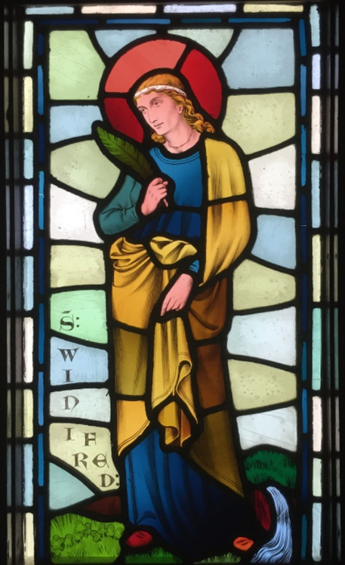
Lent 4
(27th March 2022)
Starting from today’s Scripture readings
Psalm 32.6-11

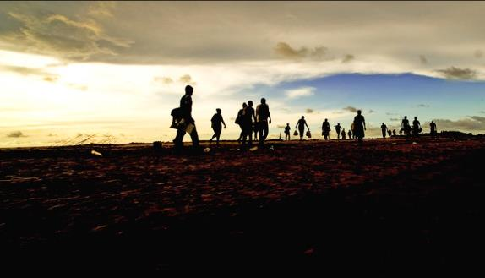
Original photo: Jairo/flickr - pilgrims
Therefore let all who are faithful offer prayer to you; at a time of distress, the rush of mighty waters shall not reach them. You are a hiding place for me; you preserve me from trouble; you surround me with glad cries of deliverance. Selah. I will instruct you and teach you the way you should go; I will counsel you with my eye upon you. Do not be like a horse or a mule, without understanding, whose temper must be curbed with bit and bridle, else it will not stay near you. Many are the torments of the wicked, but steadfast love surrounds those who trust in the LORD. Be glad in the LORD and rejoice, O righteous, and shout for joy, all you upright in heart.

1 Something to talk about together
*When have you experienced God’s steadfast love? How could we show others the faithfulness and love of God from within our own lives and Christian practice?
*How does the story of St Winefride’s death and restoration illuminate the psalmist’s words ‘you preserve me from trouble; you surround me with glad cries of deliverance’?
2 Something to reflect on
*In your Christian life, where do you mostly receive teaching and counsel? And who do you trust most to teach Christians about the faith? If you had someone come to you asking to learn about Christian faith what would you offer them?
*In the story of St Winefride, Winefride spends a long time talking to her uncle and spiritual mentor, St Beuno. After entering the religious life, she continues to communicate with him, send him items and pray for him. This suggests teachers of the faith also need help and support. How do we support clergy, bishops, elders and all teachers of the faith? And what might they learn from us?
3 Something to do
*The psalmist points to the power of prayer and the faithfulness of God in responding to prayer. This Lent, find ONE thing you could do in your church which would help people think about the power of prayer. Depending on the tradition of your church, you could make prayer cards for people to take away or give out to neighbours and friends; you could encourage people to light a candle, or you could get children to paint stones or make pictures that say ‘I prayed for…’ on one side and a picture of the intention on the other side. Those stones or pictures could later be incorporated into an Easter Garden or display.
*In the story of St Winefride, the power of prayer is very clear, not only when St Beuno prays for her vindication and restoration, but in her subsequent life within a religious order. In your own life, or within your church, find ONE thing you could do to show others more of the power of prayer, perhaps referring back to the importance of prayer in the Winefride story. How could you do more to help people to pray more confidently and more often?
4 Going Deeper
*The psalmist asks us to reflect more deeply on our relationship with God and that when we are stressed and anxious about what might happen we can trust in God’s faithfulness. This reflection and understanding through prayer and meditation culminates in an outburst of joyful praise. Do we sometimes forget to offer our Lord joyful praise and thank Jesus for everything God has done?
*In the story of St Winefride, there is a tradition that St Beuno sat on a stone by the new spring of water and promised in the name of God that "that whosoever on that spot should thrice ask for a benefit from God in the name of St. Winefride would obtain the grace he asked if it was for the good of his soul." In our daily lives, how often do you pay attention to what is needed ‘for the good of your soul’. Where do you get such spiritual nourishment and who might help you find out what those good things are?

5 A Prayer
Lord Jesus Christ,
We thank you that you are the God who never gives up;
that we can put all our trust in you.
We thank you that we can always turn to you in our distress;
that you keep us like chicks beneath your wing.
May we always trust in your steadfast love
and come to you with joyful praise.
Amen

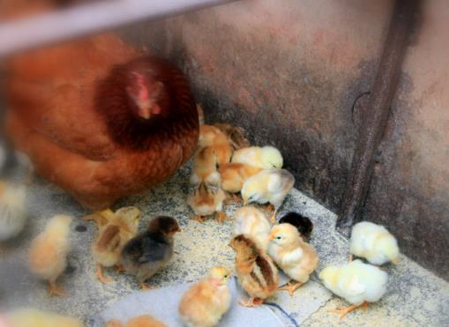
Original photo: Emilian Robert Vicol/flickr
Lent 5 (3rd April 2022)
Starting from today’s Scripture readings:
Isaiah 43:19-21

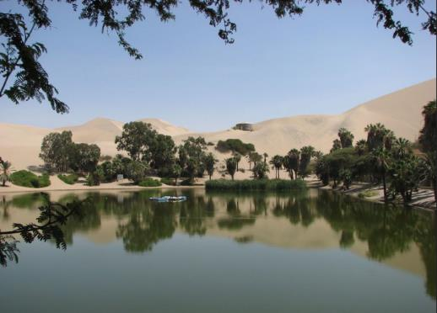
Original photo: frontriver/flickr

I am about to do a new thing; now it springs forth, do you not perceive it? I will make a way in the wilderness and rivers in the desert. The wild animals will honour me, the jackals and the ostriches; for I give water in the wilderness, rivers in the desert, to give drink to my chosen people, the people whom I formed for myself so that they might declare my praise.

1 Something to talk about together
*In this passage of Isaiah, we learn that animals and birds are grateful for the water God gives them in the dry desert and that God gives us what we need too. Sometimes we confuse what we need with what we want. What sort of spiritual ‘water’ might we need today to grow in faithfulness and discernment of God’s purposes. What kinds of spiritual ‘water’ are people looking for in their spiritual search outside the Christian faith?
*In the story of St Winefride, God indeed does a new thing when a spring of water appears at the site of her healing and which can still be visited today. How might the people who visit the spring discover more of God’s amazing love and compassion and how can we help them to do that?
2 Something to reflect on
*What do you think ‘the people whom I formed for myself’ means? In your Christian life, are you aware of having been chosen, nourished and led by God? Have you ever encountered a ‘desert’ in your spiritual life, or had times of struggle? Where do we find help in times of spiritual dryness, and when have you discovered God doing s ‘new thing’ in your life?
*In the story of St Winefride, God does an amazing new thing in restoring her to life and giving her back the life of dedication to Jesus which she wants to pursue. Water becomes an important symbol of healing and hope. How could this story help us talk about healing and hope to others and the wonderful new things God can do in people’s lives?
3 Something to do
*In all kinds of ways, people in modern society thirst for water in the desert. But they often don’t have the words to explain exactly what they want or need or are worried about talking about their experiences of God in their lives in case they are laughed at. In your Christian life, or in your church, put together some conversation starters that would allow people to share their story or ask questions.
*In the story of Winefride, a miracle happens, and she is restored to life and a new spring of water emerges. People outside the church are often very interested in stories about miracles and marvellous events. But what would people today describe as a ‘miracle’? Do some research and have a look in books or online for examples of modern miracles. How could we witness to the power of God through the Holy Spirit in talking to people about miracles?
4 Going Deeper
*Have you ever experienced a deep spiritual thirst? What do you turn to when you need refreshment and new inspiration in your spiritual life and Christian practice?
*In the story of St Winefride, her death and restoration take place outside and the healing spring which emerges is a natural phenomenon in the open air. What kinds of public event now show people what Christian faith is all about and how could we contribute better to sharing our faith in the public square?

5 A Prayer
Lord, Jesus Christ,
We thank you that you guide us to rivers in the desert.
We thank you that you give us living water to drink,
and that you fill us, your people, only with good things.
Teach us always to be thankful for your guiding hand,
for springs of refreshment and inspiration,
and help us to lead all others who thirst for hope,
to your overflowing mercy, grace and love.
Amen
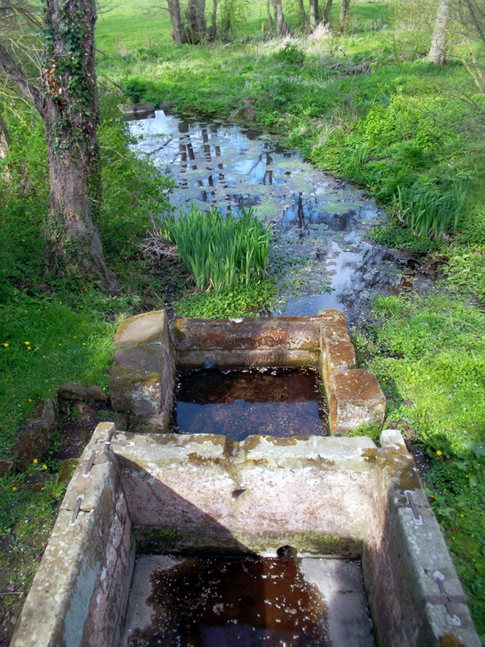
The Baths at St. Winifred's Well, near Woolston, Shropshire cc-by-sa/2.0 - © Des Blenkinsopp - geograph.org.uk/p/2945521

